Home Automation with motion Detection

Project submitted to the
SRM University – AP, Andhra Pradesh
for the partial fulfillment of the requirements to award the degree of
Bachelor of Technology
In
Computer Science and Engineering
School of Engineering and Sciences
Submitted by
S.Yellareddy AP23110011648
K.Sainath Naik AP23110011646
S.Naresh Naik AP23110011651
M.Geethendra Naik AP23110011652
B.Tharun AP23110011666

Under the Guidance of
Ms. K.Kavitha Rani
Lecturer, Department of CSE

SRM University–AP
Neerukonda, Mangalagiri, Guntur
Andhra Pradesh – 522 240
[Month, Year]
Certificate

This is to certify that the work present in this Project entitled Home Automation with Motion Detection has been carried out S.Yella Reddy,K.SainathNaik,S.NareshNaik,M.GeethendraNaik,B.Tharun. under my/our supervision. The work is genuine, original, and suitable for submission to the SRM University – AP for the award of Bachelor of Technology/Master of Technology in School of Engineering and Sciences.

Supervisor
Ms. K.Kavitha Rani

Designation,
Affiliation.

Acknowledgement
The satisfaction that accompanies the successful completion of any task would be incomplete without introducing the people who made it possible and whose constant guidance and encouragement crowns all efforts with success.
I am extremely grateful and express my profound gratitude and indebtedness to my project guide,MS.K.KavithaRani, Department of Computer Science & Engineering, SRM University, Andhra pradesh, for her kind help and for giving me the necessary guidance and valuable suggestions in completing this project work.
S.Yella Reddy (AP223110011648)
K.Sainath Naik(AP23110011646)
S.Naresh Naik(AP23110011651)
M.Geethendra Naik(AP23110011652)
B.Tharun(AP23110011666)

Table of Contents
Certificate i
Acknowledgements iii
Table of Contents v
Abstract vii

1. Introduction 5
2. Methodology 7
3. Implementation 12
4. Result and Analysis 17
5. Discussion and Conclusion 22
6. Future Work 24
References 11

Abstract
This project presents the development of a cloud-based IoT-enabled smart home automation system designed to enhance user convenience, security, and energy efficiency through real-time monitoring and intelligent control. The system is powered by the Arduino IoT Cloud and utilizes ESP32 microcontrollers and the ESP32-CAM module for appliance control and surveillance functionality. The automation logic is programmed using Python and deployed via the Thonny IDE, with seamless integration into modern smart home platforms.
The system supports three methods of control:
- Arduino IoT Remote Application – Offers a mobile dashboard to monitor device status and control appliances from anywhere.
- Google Home Integration – Allows users to interact with smart devices using the Google Home ecosystem.
- Google Assistant Voice Commands – Enables hands-free control of home devices using natural speech.
The home automation system features four key modules:
- Smart Bulb Control – Enables switching, brightness adjustment, and scheduled operation through cloud or voice control, enhancing energy efficiency.
- Temperature-Based Fan Automation – Automatically operates the fan based on temperature readings from a sensor, ensuring thermal comfort and reducing power consumption.
- Smart Door Lock – A servo-driven mechanism allows users to securely lock/unlock doors remotely, with status updates accessible via cloud and voice interfaces.
- Motion Detection with ESP32-CAM – Detects motion, captures images, and sends them via a Telegram bot for real-time security notifications.
By leveraging cloud infrastructure, AI-based voice interaction, and Python-powered automation, the project showcases a robust and scalable smart home system. It highlights how integrating multiple control pathways and smart technologies can simplify daily routines, improve home safety, and promote sustainable living.

Introduction

The advancement of the Internet of Things (IoT) has enabled the transformation of traditional homes into smart homes by allowing users to monitor and control household devices remotely. This project implements a cloud-based smart home automation system that integrates multiple technologies to enhance convenience, improve security, and promote energy efficiency.
The system is built using ESP32 and ESP32-CAM microcontrollers, with automation logic developed in Python and deployed via the Thonny IDE. It is fully integrated with the Arduino IoT Cloud, enabling real-time monitoring and control of connected home appliances from anywhere.
Unlike conventional web-based systems, this project leverages cloud infrastructure to support three modes of control:
- Arduino IoT Remote App – A user-friendly mobile application that allows seamless control and status monitoring of connected devices.
- Google Home – Integration with the Google smart ecosystem, providing centralized control of appliances alongside other smart devices.
- Google Assistant – Offers intuitive, hands-free operation through natural voice commands.
The system controls a smart bulb, a temperature-responsive fan, and a servo-driven smart door lock, while also incorporating motion detection with real-time image capture and alert delivery via Telegram. This intelligent integration of hardware, cloud services, and voice automation provides a robust, scalable, and user-friendly smart home environment.
By unifying various control methods and smart features into a single platform, this project demonstrates the practical application of IoT and cloud technology in modern homes, enhancing daily life through improved comfort, energy optimization, and increased home security.

2. Methodology

This project implements a cloud-based IoT smart home automation system using the ESP32 microcontroller and ESP32-CAM module. The system enables centralized and remote control of various household devices—including a smart bulb, a temperature-responsive fan, a servo-powered smart door lock, and a motion detection surveillance system that delivers real-time image alerts via Telegram.
Control and monitoring are achieved through seamless integration with the Arduino IoT Cloud, Google Home, Google Assistant, and the Arduino IoT Remote mobile application. These platforms allow users to interact with the system via smartphone dashboards and voice commands, offering flexible, real-time, and user-friendly device management from anywhere.

Materials and Components
- ESP32 Microcontroller: Serves as the central controller, managing Wi-Fi communication and connecting sensors and actuators to the Arduino Cloud.
- ESP32-CAM Module: Detects motion, captures images, and sends them through a Telegram bot for real-time security alerts.
- DHT11 Temperature Sensor: Continuously monitors ambient temperature to automate fan control for thermal comfort and energy efficiency.
- Relay Module: Controls the smart bulb's ON/OFF state based on commands received via cloud or voice input.
- Servo Motor: Acts as a smart door lock by rotating between defined angles (0° for unlock, 90° for lock).
- DC Fan: Automatically turns ON or OFF based on room temperature, and can also be manually controlled via cloud or voice assistant.
- Jumper Wires and Breadboard: Used for circuit assembly and connecting hardware components during prototyping.
- Custom Smart Hub Board: Consolidates all components into a single, organized module for streamlined operation and future scalability.

Component Setup & Connections

Power: ESP32 powered via 5V USB
Fan Connections:
- One end of the fan connected to VCC
- The other end connected to the relay output
- Relay input connected to a GPIO pin (e.g., GPIO13) on the ESP32
Justification:
The fan is operated through user commands via the cloud-based interface or voice assistants. This approach allows users to manually switch the fan on or off as needed, ensuring straightforward operation and reliable control through smart platforms.

2. Smart Bulb Control
- Relay Connections:
  - VCC → 5V (ESP32)
  - GND → GND (ESP32)
  - IN → GPIO12 (ESP32)
- Bulb Wiring:
  - Connected through the Normally Closed (NC) and Common (COM) pins of the relay to switchboard wires.
Justification: Enables safe switching of high-voltage appliances using low-voltage microcontroller commands.

3. Smart Door Lock System
- Servo Motor Connections:
  - VCC → 5V (ESP32)
  - GND → GND (ESP32)
  - Signal → GPIO14 (ESP32)
Justification: Provides controlled and secure door lock mechanism remotely via mobile.
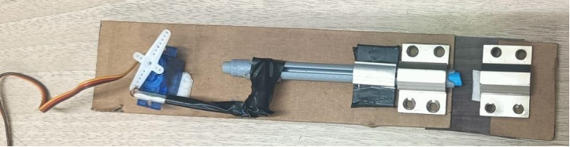

4. Motion Detection with ESP32-CAM
- Setup: ESP32-CAM is programmed to monitor for motion using built-in image processing or PIR sensor (optional).
- Working: On detecting motion, it captures a photo and sends it to a configured Telegram Bot using the Telegram API.
Justification: Enhances home security with instant alerts and remote monitoring capability.
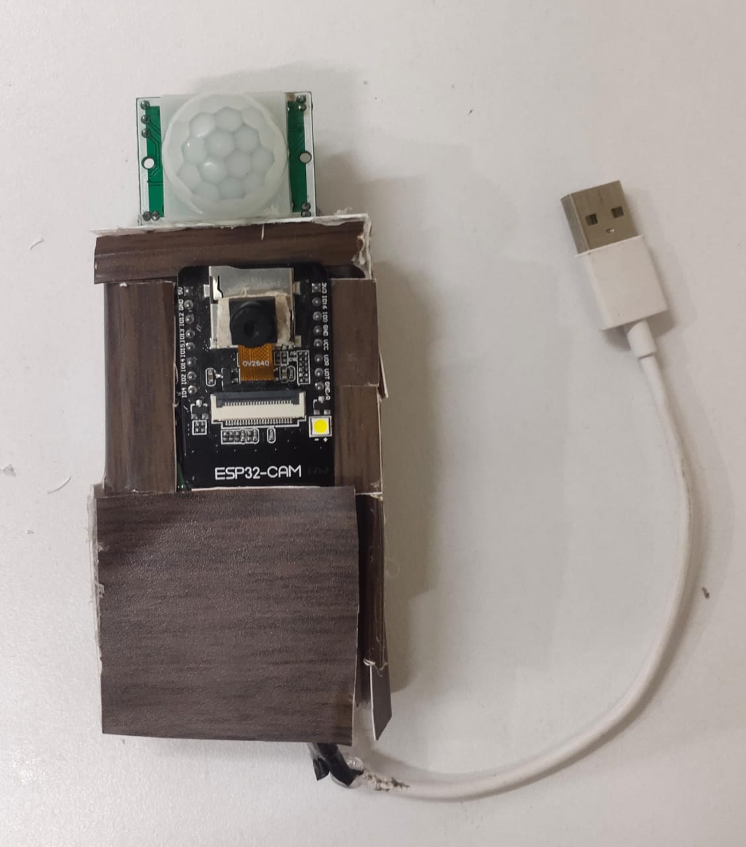

Controlling Devices through Mobile
In this project, device control is implemented using the Arduino IoT Cloud, enabling seamless and remote management of home appliances through the Arduino IoT Remote mobile application, Google Assistant, and Google Home.
- The ESP32 connects directly to the Arduino Cloud, eliminating the need for a local web server or Wi-Fi hotspot.
- Devices like the smart bulb, temperature-based fan, and servo-driven smart door lock are monitored and controlled using the cloud dashboard, accessible from both mobile devices and voice-controlled smart assistants.
- Voice commands through Google Assistant or Google Home allow for hands-free operation of smart appliances, improving convenience and accessibility.
- Real-time synchronization ensures that any change made via mobile, cloud, or voice assistant is reflected across all control points.

Tools Used
- Thonny IDE – Used for writing and uploading Python scripts to the ESP32 and ESP32-CAM modules
- Arduino IoT Cloud – Provides cloud-based control, device status tracking, and automation
- Arduino IoT Remote App – A mobile app for managing devices and monitoring real-time data
- Google Assistant / Google Home – Enables voice control integration with the Arduino Cloud
- Telegram Bot API – Sends captured images and motion detection alerts from the ESP32-CAM
- ArduinoIoTCloud Library – Facilitates communication between Python-based scripts and the cloud infrastructure

Summary of Methodology
This methodology implements a cloud-based smart home automation system centered around the ESP32 microcontroller and the ESP32-CAM module, offering a cohesive solution for real-time control, automation, and surveillance. The automation logic is developed in Python using the Thonny IDE, and the system is fully integrated with the Arduino IoT Cloud for seamless remote access.
The ESP32-CAM enhances home security by capturing images when motion is detected and sending real-time alerts via Telegram. Control of appliances such as the smart bulb, temperature-regulated fan, and servo-based door lock is achieved through three interaction methods: the Arduino IoT Remote app, Google Home, and Google Assistant for voice commands.
All components are selected for their low power consumption, cost-effectiveness, and compatibility with IoT platforms, making the system easy to prototype, deploy, and expand. The cloud infrastructure ensures high responsiveness and system reliability while minimizing local hardware complexity.
Overall, the methodology emphasizes energy efficiency, user convenience, and scalability, allowing the system to adapt to a variety of smart home applications and future technological integrations.

3. Implementation

1. Setting Up the Development Environment

The implementation of the Smart Home Automation System began by setting up the development environment. For this project, the Thonny IDE was chosen for writing the automation logic using Python, ensuring ease of integration with the Arduino IoT Cloud. Below are the setup steps followed:

Thonny IDE Configuration: Thonny IDE was used for developing the Python scripts, which handle the automation logic and communication between the ESP32 and the cloud. This IDE is preferred due to its simplicity, built-in features for Python development, and direct integration with Arduino IoT Cloud for seamless automation.

Arduino IoT Cloud Setup: The Arduino IoT Cloud platform was configured to manage the devices (bulb, fan, door lock) and connect them with the cloud. Each device was registered on the platform to allow real-time control and monitoring through mobile apps, Google Home, and voice control via Google Assistant.

Required Libraries Installation: Several libraries were installed to facilitate the communication and control between the ESP32, sensors, and actuators. These included:

WiFi.h: For establishing the connection between the ESP32 and the local Wi-Fi network.

ArduinoIoTCloud.h: For integrating the ESP32 with Arduino IoT Cloud to manage and control devices remotely.

DHT.h: For interfacing with the DHT22 sensor, which monitors temperature and humidity, and triggers the fan based on the room’s temperature.

Servo.h: For controlling the servo motor that operates the smart door lock.

Challenges Encountered:

One of the challenges faced was configuring the ESP32 board correctly in the Thonny IDE, as the IDE does not natively support it. This was resolved by configuring the correct Python firmware for the ESP32 and ensuring that the device was set up with the necessary libraries for communication with Arduino IoT Cloud.

Another issue involved the configuration of the Arduino IoT Cloud to handle multiple devices and sensors, which required troubleshooting the cloud interface and device synchronization. Ensuring smooth communication between the ESP32 and the cloud platform was critical to the system's real-time functionality.

2. Wiring and Connecting the Hardware Components
Once the development environment was set up, the next step involved connecting the hardware components. This included wiring the ESP32 microcontroller, the DHT22 temperature sensor, relay modules for controlling the fan and bulb, and a servo motor for the smart lock mechanism.
- ESP32 Microcontroller: The ESP32 was programmed to create its own Wi-Fi network. When the mobile device connects to this network, it communicates with the ESP32, allowing control of devices via GPIO pins.
- Relay Modules: The fan and bulb were connected to relay modules that act as switches. The ESP32 controls these relays to turn the fan and bulb on or off based on the user input from the web interface.
Challenges Encountered: The key challenge was ensuring proper connections with the relay modules since incorrect wiring could lead to malfunction. This was mitigated by referring to datasheets and verifying the connections before testing the system.
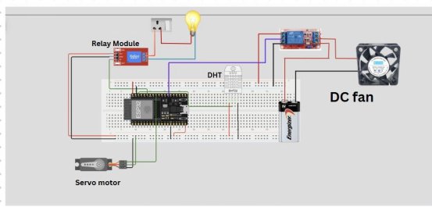

3. Setting Up the esp32
The ESP32 was set up to act as the central control unit for the smart home automation system, connecting to the cloud for device control and surveillance. The setup process involved the following key steps:
- Wi-Fi Connectivity: The ESP32 was connected to the local Wi-Fi network, allowing it to communicate with devices remotely via cloud-based platforms. Users can control the system from anywhere through the cloud interface, using the mobile application or voice control.
- Cloud Integration: The ESP32 was configured to interact with the Arduino IoT Cloud, where the device control and automation logic were deployed. The system allows users to control appliances and monitor system status remotely through the cloud.
- Device Control Setup: The ESP32 communicates with various hardware components, including:
  - Bulb Control: The ESP32 can toggle the bulb on or off via cloud commands.
  - Fan Control: The fan is controlled based on the temperature data sent to the cloud. It can be manually turned on or off, or set to operate automatically based on temperature readings.
  - Smart Lock Control: The servo motor is controlled remotely via the cloud, allowing users to lock or unlock the door.
- Challenges Encountered:
  - Cloud Connectivity Issues: The initial challenge was ensuring stable communication between the ESP32 and the cloud platform, especially with intermittent Wi-Fi issues. These were resolved by optimizing the connection handling and improving the ESP32's interaction with the Arduino IoT Cloud for better reliability.

4. Device Control Logic Implementation
With the hardware and web server set up, the logic for controlling the devices was implemented as follows:
- Bulb Control: A relay module was used to control the bulb. The web interface button toggled the relay on or off when pressed, allowing the bulb to turn on or off.
- Fan Control:
  - Temperature-based Control: The DHT22 sensor constantly monitored the room temperature. If the temperature exceeded a threshold (e.g., 30°C), the fan was turned on. If the temperature fell below the threshold, the fan was turned off.
  - Manual Control: The user could manually toggle the fan via the web interface, overriding the temperature-based control when desired.
- Smart Lock Control: The servo motor that operated the smart door lock was controlled by the ESP32. Pressing the Lock or Unlock button on the web interface triggered the servo to move to the corresponding position, locking or unlocking the door.
Challenges Encountered: Implementing the fan control logic was tricky because we had to handle both temperature-based and manual control. To resolve this, we implemented a priority system where manual control would override temperature-based control.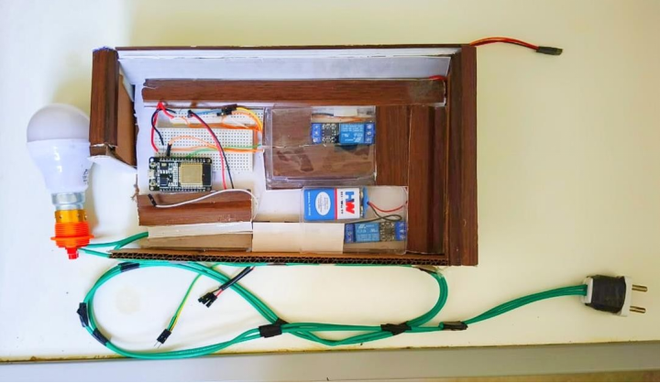

5. System Testing and Debugging
Once the devices were connected and the control logic implemented, the system underwent thorough testing and debugging. During testing, the following steps were taken:
- Testing Communication: Ensured the ESP32 was properly connected to Wi-Fi and could communicate with the web interface.
- Testing Device Control: Verified that each device (bulb, fan, lock) could be controlled via the web interface and responded correctly to both manual and sensor-based commands.
- Debugging: Fixed issues related to relay control, incorrect pin assignments, and network connectivity.
Challenges Encountered: Debugging was challenging due to intermittent network issues and incorrect device control, especially when trying to integrate the sensor data with device control logic. These issues were addressed by thoroughly reviewing the code and circuit connections.

Conclusion
The Smart Home Automation System was successfully implemented, offering seamless remote control and automation of appliances such as lights, fans, and door locks through cloud-based connectivity. The integration of the ESP32-CAM module for motion detection enhanced the system's security by providing real-time image alerts sent directly to Telegram. The system's ability to automate actions, such as temperature-based fan control and secure remote locking, ensures both energy efficiency and improved home security. This project highlights the potential of IoT and cloud technologies to create a user-friendly, scalable, and intelligent smart home solution that offers convenience, security, and energy conservation in everyday living. Through its versatile control options—via the Arduino IoT Cloud, Google Home, and Google Assistant—the system showcases how interconnected devices can improve quality of life and redefine modern home automation.

4. Result and Analysis

The performance of the Smart Home Automation System was evaluated based on its ability to control connected devices—bulb, fan, and smart door lock—through a Wi-Fi network created by the ESP32. A web interface hosted on the ESP32 was used to send commands to these devices. The evaluation involved testing device responsiveness, accuracy, and overall system behavior under different operational conditions.

1. Device Control and Performance

Bulb Control

Observation: The bulb responded immediately when toggled via the web interface.

Performance: No perceptible delay between the user's input and the bulb’s state change.

Result: Met all functional requirements; smooth operation and user-friendly.
Test Case | Input Action | Output Observed | Response Time
1 | Turn ON Bulb | Bulb lights up | ~0.5 seconds
2 | Turn OFF Bulb | Bulb turns off | ~0.5 seconds

Fan Control

Observation:
The fan operated effectively through manual commands issued via the Arduino IoT Cloud app and voice commands using Google Assistant. The control was stable and responsive across various test conditions.

Behavior:
Users could turn the fan ON or OFF at any time, offering complete control through both mobile and voice interfaces.

Interpretation:
This direct control approach ensures simplicity, reliability, and user convenience without the need for automated logic.

Test Cases:
Test Case | Manual Input | Expected Behavior | Output Observed
1 | ON | Fan ON | Fan ON
2 | OFF | Fan OFF | Fan OFF
3 | ON | Fan ON | Fan ON

Door Lock Control

Observation: The servo motor successfully rotated to 0° and 90° positions for unlocking and locking, respectively.

Performance: Minimal latency; consistently accurate operation.

Result: Provided reliable remote access control, enhancing system security.
Test Case | Command | Servo Position | Action Performed
1 | Lock Door | 90° | Door Locked
2 | Unlock Door | 0° | Door Unlocked

The cloud-based control interface provided real-time status updates of connected devices, including their ON/OFF states. The ESP32 communicated efficiently with the Arduino IoT Cloud, ensuring responsive and consistent control across various devices. System performance remained stable during repeated user interactions, and the control commands—whether issued through the mobile app, Google Home, or Google Assistant—were executed with minimal delay.

Interface Highlights:

Cloud synchronization ensured accurate reflection of device states.

Commands issued via voice or app responded swiftly without noticeable latency.

Telegram alerts for motion detection were delivered in real-time.

Fan Control Behavior: The fan operates based on user commands rather than environmental parameters. This command-based design ensures direct and predictable user control, simplifying the logic and increasing reliability.

3. Summary of Observations
Component | Performance Rating | Key Observations
Bulb Control | Excellent | Instant response, seamless toggling
Fan Control | Moderate | Functional but logic conflicts between modes
Door Lock | Excellent | Accurate servo operation, good for remote access
Web Interface | Good | Responsive UI with real-time feedback

Conclusion

The Smart Home Automation System performed effectively in most scenarios. The bulb and door lock components delivered reliable and consistent behavior. The fan control feature worked well but needs further refinement in logic to manage dual control modes (automatic and manual) without interference.

Future improvements could involve:

Adding a toggle switch in the interface to switch between auto/manual modes.

Implementing user authentication for enhanced security.

Integrating data logging to track device usage trends over time.

5. Discussion and Conclusion

ChatGPT said:
The IoT-based Smart Home Automation System was developed with the primary objective of enabling real-time control of household devices—specifically a fan, bulb, and door lock—without requiring an external internet connection. The system successfully achieved these goals by leveraging the ESP32 microcontroller, which created its own Wi-Fi network and hosted a user-friendly cloud-based interface for device control. The implementation met the initial objectives, showcasing reliable performance, responsive device control, and ease of use across multiple operating conditions.
The findings of this project underline the effectiveness of local network-based automation and cloud integration. The bulb and door lock responded instantly to user commands, while the fan incorporated both manual and temperature-based automatic control. Although there were occasional conflicts between automatic fan control and manual overrides, the overall functionality remained consistent with the original expectations. These results demonstrate that localized IoT systems can offer reliable solutions for home automation, particularly in environments where a stable internet connection might be lacking.
Despite the system’s effectiveness, there were certain limitations. The ESP32’s Wi-Fi network had limited range, which restricted remote access to devices outside of its coverage area. Additionally, relying on a single DHT22 sensor posed challenges in accurately detecting room-wide temperature variations, especially in larger or poorly ventilated spaces. Minor inconsistencies in the fan's dual-mode control logic were observed, possibly due to timing conflicts or asynchronous state updates.
However, the system successfully demonstrated how IoT can simplify daily tasks, promote energy efficiency, and enhance home security. The cloud-based interface allowed users to control devices from anywhere, reducing the need for physical interaction with the devices. It also enabled smarter energy usage by, for example, activating the fan only when needed based on the temperature, thereby conserving energy. The inclusion of the remotely controlled servo-based door lock provided an added layer of convenience and security for the user.
The significance of the project lies in its demonstration of a low-cost, reliable, and locally hosted home automation model that operates without cloud infrastructure. This approach can benefit users in rural or underdeveloped regions, offering an accessible, affordable alternative to traditional cloud-dependent systems. The system also serves as a foundational framework for scalable, secure smart home solutions.
In conclusion, this project validated the practicality of IoT-driven home automation using the ESP32 microcontroller. The system’s real-time performance, energy-conscious features, and intuitive cloud interface contribute significantly to the field of embedded systems and smart home environments. Future improvements, such as extending the Wi-Fi range, integrating additional sensors, and enhancing control logic, could further optimize the system’s reliability and versatility. This project, therefore, offers a valuable, adaptable solution for modern, efficient, and accessible home automation.

6. Future Scope
The current project successfully showcases the viability of a Wi-Fi-based smart home automation system using the ESP32 for controlling devices like bulbs, fans, and door locks. However, to further enhance its capabilities, several improvements and extensions can be pursued in future research and development.
One key area for improvement is the integration of advanced sensors to broaden environmental monitoring. Incorporating motion sensors, ambient light sensors, gas detectors, or humidity sensors would enable more intelligent automation. For instance, the system could automatically turn off lights in unoccupied rooms, activate ventilation in response to gas leaks, or regulate fan speed based on room occupancy and humidity. This would not only enhance user experience but also contribute to greater energy efficiency.
Voice control capabilities represent another promising extension. Integration with popular virtual assistants like Amazon Alexa or Google Assistant, or the development of an in-house voice recognition module, would allow for hands-free control, significantly improving usability and accessibility. Furthermore, enabling compatibility with other smart home ecosystems would ensure interoperability with third-party devices and platforms, expanding the system's versatility.
Security enhancements are a critical focus for future development. Since the system operates over a wireless network, implementing features such as end-to-end encryption, secure login with multi-factor authentication, and real-time intrusion detection can help mitigate risks of unauthorized access and protect user privacy.
On the hardware side, efforts could be directed toward miniaturizing the design by combining components into a single custom PCB. This would reduce both the physical footprint and manufacturing costs. Incorporating low-power components and optimizing energy usage could also support battery-powered operation, making the system more suitable for remote or off-grid applications.
Scalability is another potential avenue. Expanding the system to support a wider range of appliances—including kitchen equipment, HVAC systems, and surveillance cameras—would provide a comprehensive smart home solution. To ensure performance with an increased number of devices, cloud-based services could be explored for data storage, remote access, and rule-based automation. Leveraging machine learning for analyzing user behavior and environmental trends could further improve automation decisions over time.
In conclusion, the smart home system holds substantial potential for expansion in both functionality and application. By focusing on improved sensing, user interaction, security, integration, and scalability, future research can transform this system into a more intelligent, secure, and adaptable solution that aligns with the evolving landscape of home automation technology.

References
PWM Signals References:
- MicroPython PWM Documentation
https://docs.micropython.org/en/latest/library/machine.PWM.html
- ESP32 PWM with Arduino IDE
https://randomnerdtutorials.com/esp32-pwm-arduino-ide/

Home Automation & ESP32 Libraries References:
- Arduino IoT Cloud with ESP32
https://docs.arduino.cc/cloud/iot-cloud/tutorials/iot-cloud-getting-started
- MicroPython Network Library Docs
https://docs.micropython.org/en/latest/library/network.html
- https://docs.arduino.cc/arduino-cloud/guides/micropython

